Supplemental Table 1. Complete ‘glmmTMB’ seasonality model outputs for model 1 measuring hurricane effects on transmission strategy between direct or complex life cycle parasites, model 2 measuring hurricane effects on trematode adult, trematode metacercaria, and monogenean parasites, and model 3 measuring hurricane effects on myxozoan parasites. Bolded values represent significance and bolded model terms represent significant values on both short- and long- time scales.
3 month 6 month
response variable model term estimate std.error CI_lower CI_upper z-statistic p.value  direct or complex life cycle strategy (Intercept) seasonspring seasonsummer seasonwinter 44.6251 1.1653 0.9029 1.1030 0.1532 0.7649 0.2380 0.2931 33.0514 0.2602 0.5663 0.6210 60.2518 5.2178 1.4397 1.9592 24.7961 0.2000 -0.4289 0.3345 0.0000 0.8415 0.6680 0.7380  eventhurricane 0.8598 0.2192 0.5596 1.3212 -0.6892 0.4907  seasonspring*eventhurricane 0.9908 0.8498 0.1873 5.2407 -0.0109 0.9913  seasonsummer*eventhurricane 1.3722 0.3221 0.7299 2.5796 0.9824 0.3259  monogenean, trematode adult, trematode metacercaria seasonwinter*eventhurricane (Intercept) seasonspring seasonsummer seasonwinter eventhurricane 0.2835 0.8391 0.0547 1.4685 -1.5020 0.1331  18.2820 1.0940 1.0666 1.0970 0.6902 0.1065 0.3966 0.1722 0.1888 0.1499 14.8373 0.5028 0.7611 0.7576 0.5145 22.5265 2.3802 1.4947 1.5884 0.9260 27.2810 0.2266 0.3746 0.4903 -2.4732 0.0000 0.8208 0.7080 0.6240 0.0134  seasonspring*eventhurricane 0.6760 0.5774 0.2180 2.0963 -0.6781 0.4977  seasonsummer*eventhurricane 1.3888 0.2282 0.8879 2.1721 1.4391 0.1501  seasonwinter*eventhurricane NA NA NA NA NA NA |  |  |  |  |  |  |  |  |  |  |  |  |  |  |  | estimate std.error CI_lower CI_upper z-statistic p.value  47.5209 0.1532 35.1949 64.1639 25.2037 0.0000  0.9712 0.2825 0.5582 1.6896 -0.1036 0.9175  0.9409 0.3225 0.5000 1.7706 -0.1888 0.8503  1.0055 0.2145 0.6604 1.5308 0.0254 0.9798  0.8047 0.2043 0.5392 1.2009 -1.0635 0.2875  1.4535 0.3448 0.7394 2.8571 1.0846 0.2781  1.2873 0.3774 0.6144 2.6972 0.6692 0.5033  0.8950 0.2982 0.4989 1.6056 -0.3720 0.7099  16.2916 0.1046 13.2730 19.9968 26.6918 0.0000  1.1078 0.1888 0.7652 1.6037 0.5423 0.5876  1.0980 0.1994 0.7428 1.6232 0.4690 0.6391  1.1867 0.1413 0.8996 1.5654 1.2115 0.2257  0.8210 0.1357 0.6293 1.0710 -1.4541 0.1459  1.2045 0.2243 0.7760 1.8697 0.8296 0.4068  1.1647 0.2375 0.7312 1.8551 0.6420 0.5209  0.7882 0.1952 0.5376 1.1554 -1.2198 0.2226
 | myxozoan | (Intercept) seasonspring seasonsummer |  | 28.1111  0.9960  0.8699 | 0.1598  0.6967  0.2604 |  | 20.5518  0.2543  0.5222 |  | 38.4508  3.9021  1.4492 |  | 20.8767  -0.0057  -0.5351 |  | 0.0000  0.9955  0.5926 |  |  |  | 28.4286  0.7309  0.7739 |  | 0.1619  0.2980  0.3459 |  | 20.6990  0.4076  0.3928 |  | 39.0445  1.3107  1.5244 |  | 20.6768  -1.0521  -0.7411 |  | 0.0000  0.2928  0.4586
 |  | seasonwinter |  | 0.9664 | 0.3199 |  | 0.5162 |  | 1.8092 |  | -0.1068 |  | 0.9149 |  |  |  | 0.8375 |  | 0.2297 |  | 0.5340 |  | 1.3137 |  | -0.7721 |  | 0.4401
 |  | eventhurricane | 0.6448 |  |  | 0.2356 |  | 0.4063 |  | 1.0231 |  | -1.8631 |  | 0.0625 |  |  |  | 0.5319 |  | 0.2224 |  | 0.3439 |  | 0.8225 |  | -2.8389 |  | 0.0045
 |  | seasonspring*eventhurricane | 1.0967 |  |  | 0.7812 |  | 0.2372 |  | 5.0705 |  | 0.1182 |  | 0.9059 |  |  |  | 2.1642 |  | 0.3678 |  | 1.0525 |  | 4.4501 |  | 2.0992 |  | 0.0358
 |  | seasonsummer*eventhurricane | 1.7366 |  |  | 0.3460 |  | 0.8814 |  | 3.4213 |  | 1.5952 |  | 0.1107 |  |  |  | 2.2256 |  | 0.4074 |  | 1.0015 |  | 4.9458 |  | 1.9638 |  | 0.0496
 |  | seasonwinter*eventhurricane | NA |  |  | NA |  | NA |  | NA |  | NA |  | NA |  |  |  | 1.2821 |  | 0.3316 |  | 0.6694 |  | 2.4555 |  | 0.7494 |  | 0.4536

Supplemental Table 2. Complete ‘glmmTMB’ conditional model outputs for model 1 measuring hurricane effects on transmission strategy between direct or complex life cycle parasites, model 2 measuring hurricane effects on trematode adult, trematode metacercaria, and monogenean parasites, and model 3 measuring hurricane effects on myxozoan parasites. Bolded values represent significance and bolded model terms represent significant values on both short- and long- time scales.

direct | (Intercept) eventhurricane timingpost | 1.0324  1.4600  1.4326 | 0.8113  0.5812  0.5566 | 0.2105  0.4673  0.4813 | 5.0632  4.5612  4.2646 | 0.0393  0.6511  0.6460 | 0.9687  0.5150  0.5183 | 1.0756  1.3311  1.1933 | 0.5815  0.3336  0.3712 | 0.3441  0.6923  0.5765 | 3.3621  2.5595  2.4702 | 0.1253  0.8574  0.4762 | 0.9003  0.3912  0.6339
 | life_historyComplex | 0.3707 | 0.7143 | 0.0914 | 1.5031 | -1.3894 | 0.1647 | 0.4428 | 0.6360 | 0.1273 | 1.5400 | -1.2811 | 0.2002
3 month 6 month
response  variable | reference term |  | model term | estimate | std.error | CI_lower | CI_upper | z-statistic | p.value
direct or  complex life cycle | complex | (Intercept) eventhurricane timingpost life_historyDirect mill_locationbelow eventhurricane*timingpost eventhurricane*life_historyDirect timingpost*life_historyDirect |  | 0.3827  0.7349  1.1577  2.6978  0.7728  1.1580  1.9866  1.2374 | 0.6618  0.5776  0.5676  0.7143  0.2693  0.7558  0.4724  0.5142 | 0.1046  0.2369  0.3806  0.6653  0.4558  0.2632  0.7871  0.4516 | 1.4002  2.2798  3.5218  10.9400  1.3101  5.0941  5.0141  3.3904 | -1.4514  -0.5332  0.2581  1.3894  -0.9572  0.1941  1.4531  0.4143 | 0.1467  0.5939  0.7964  0.1647  0.3385  0.8461  0.1462  0.6787
 |  | eventhurricane*timingpost*life_historyDirect |  | 0.1988 | 0.6764 | 0.0528 | 0.7484 | -2.3885 | 0.0169
estimate CI_lower CI_upper std.error z-statistic p.value
0.4762 0.3698 0.2307 0.9830 -2.0062 0.0448
1.1808 0.3302 0.6182 2.2557 0.5033 0.6147
0.8683 0.3464 0.4404 1.7120 -0.4078 0.6834
2.2586 0.6360 0.6493 7.8561 1.2811 0.2002
1.1227 0.1475 0.8409 1.4989 0.7850 0.4325
1.3417 0.3988 0.6140 2.9316 0.7371 0.4611
1.1273 0.4068 0.5079 2.5021 0.2945 0.7684
1.3744 0.4471 0.5722 3.3011 0.7113 0.4769
0.3853 0.5134 0.1409 1.0538 -1.8579 0.0632
 | mill_locationbelow |  | 0.7728 | 0.2693 | 0.4558 | 1.3100 | -0.9572 | 0.3384 | 1.1227 | 0.1475 | 0.8409 | 1.4989 | 0.7849 | 0.4325
 | eventhurricane*timingpost |  | 0.2302 | 0.7861 | 0.0493 | 1.0747 | -1.8684 | 0.0617 | 0.5169 | 0.4216 | 0.2262 | 1.1812 | -1.5650 | 0.1176
 | eventhurricane*life_historyComplex |  | 0.5034 | 0.4724 | 0.1994 | 1.2705 | -1.4531 | 0.1462 | 0.8871 | 0.4068 | 0.3997 | 1.9690 | -0.2945 | 0.7684
 | timingpost*life_historyComplex |  | 0.8081 | 0.5142 | 0.2950 | 2.2142 | -0.4143 | 0.6787 | 0.7276 | 0.4471 | 0.3029 | 1.7476 | -0.7114 | 0.4769
 | eventhurricane*timingpost*life_historyComplex |  | 5.0303 | 0.6764 | 1.3362 | 18.9379 | 2.3885 | 0.0169 | 2.5956 | 0.5134 | 0.9490 | 7.0995 | 1.8580 | 0.0632
monogenean,  trematode adult,  trematode metacercaria | (Intercept) eventhurricane timingpost psite_typetrematode psite_typetrematode_metacercaria mill_locationbelow  monogenean eventhurricane*timingpost |  | 2.9847  1.1492  0.6086  0.3755  1.3965  1.1619  0.5858  0.5204  0.1319  1.6167  0.1981  4.4669  10.4622  4.1682  0.1516  0.1206  0.2689  0.7161  1.1619 | 0.7699  0.5611  0.5734  0.8500  0.9986  0.3068  0.7800  0.5417  0.7680  0.5472  0.8263  0.8142  0.9973  0.7861  0.7686  0.8041  0.8827  0.9986  0.3068 | 0.6600  0.3827  0.1978  0.0710  0.1973  0.6368  0.1270  0.1800  0.0293  0.5532  0.0392  0.9056  1.4814  0.8930  0.0336  0.0249  0.0477  0.1011  0.6368 | 13.4978  3.4513  1.8725  1.9868  9.8864  2.1199  2.7020  1.5047  0.5943  4.7247  1.0006  22.0339  73.8869  19.4563  0.6839  0.5831  1.5169  5.0694  2.1199 | 1.4203  0.2479  -0.8660  -1.1523  0.3345  0.4891  -0.6856  -1.2057  -2.6376  0.8779  -1.9592  1.8382  2.3541  1.8160  -2.4544  -2.6309  -1.4880  -0.3345  0.4891 | 0.1555  0.8042  0.3865  0.2492  0.7380  0.6248  0.4930  0.2279  0.0083  0.3800  0.0501  0.0660  0.0186  0.0694  0.0141  0.0085  0.1368  0.7380  0.6248 | 1.7263  1.3959  1.3419  0.3727  0.9362  1.1506  0.4737  1.1439  0.4220  1.1533  0.2413  2.1532  5.2435  1.5894  0.6007  0.3362  0.3954  1.1194  1.1591 | 0.5902  0.3409  0.3702  0.6848  0.8739  0.1510  0.4200  0.4224  0.6399  0.4676  0.6968  0.5470  0.8465  0.6625  0.5525  0.5845  0.7386  0.8218  0.1525 | 0.5429  0.7157  0.6495  0.0974  0.1688  0.8559  0.2080  0.4998  0.1204  0.4613  0.0616  0.7370  0.9979  0.4338  0.2034  0.1069  0.0930  0.2236  0.8595 | 5.4892  2.7228  2.7725  1.4265  5.1913  1.5469  1.0790  2.6179  1.4793  2.8835  0.9454  6.2907  27.5511  5.8233  1.7740  1.0572  1.6817  5.6037  1.5630 | 0.9251  0.9785  0.7942  -1.4413  -0.0754  0.9294  -1.7790  0.3182  -1.3481  0.3050  -2.0406  1.4022  1.9576  0.6994  -0.9224  -1.8648  -1.2562  0.1372  0.9678 | 0.3549  0.3278  0.4271  0.1495  0.9399  0.3527  0.0752  0.7503  0.1776  0.7604  0.0413  0.1609  0.0503  0.4843  0.3563  0.0622  0.2091  0.8908  0.3332
 | trematode | eventhurricane*psite_typetrematode eventhurricane*psite_typetrematode_metacercaria timingpost*psite_typetrematode timingpost*psite_typetrematode_metacercaria eventhurricane*timingpost*psite_typetrematode  eventhurricane*timingpost*psite_typetrematode_metacercaria  (Intercept) eventhurricane timingpost psite_typetrematode psite_typemonogenean mill_locationbelow
 | metacercaria
 | eventhurricane*timingpost |  | 6.1289 | 0.9966 | 0.8690 | 43.2254 | 1.8191 | 0.0689 | 2.3013 | 0.7074 | 0.5752 | 9.2070 | 1.1782 | 0.2387
 | eventhurricane*psite_typetrematode |  | 3.9451 | 0.7751 | 0.8636 | 18.0214 | 1.7708 | 0.0766 | 2.6818 | 0.6002 | 0.8271 | 8.6957 | 1.6437 | 0.1002
 | eventhurricane*psite_typemonogenean |  | 7.5803 | 0.7680 | 1.6826 | 34.1494 | 2.6376 | 0.0083 | 2.2778 | 0.5852 | 0.7234 | 7.1724 | 1.4066 | 0.1595
 | timingpost*psite_typetrematode |  | 8.1598 | 0.7871 | 1.7445 | 38.1672 | 2.6670 | 0.0077 | 4.7628 | 0.6405 | 1.3573 | 16.7128 | 2.4370 | 0.0148
 | timingpost*psite_typemonogenean |  | 5.0473 | 0.8263 | 0.9994 | 25.4915 | 1.9592 | 0.0501 | 3.8808 | 0.6398 | 1.1074 | 13.5998 | 2.1195 | 0.0341

eventhurricane*timingpost*psite_typetrematode 0.4270 1.0282 0.0569 3.2036 -0.8277 0.4078 0.4301 0.7774 0.0937 1.9739 -1.0853 0.2778 eventhurricane*timingpost*psite_typemonogenean 0.0956 0.9973 0.0135 0.6750 -2.3541 0.0186 0.2159 0.7641 0.0483 0.9655 -2.0060 0.0449

(Intercept) 0.1259 0.8654 0.0231 0.6867 -2.3944 0.0166 0.0617 0.7475 0.0143 0.2670 -3.7266 0.0002 eventhurricane 0.3158 0.9239 0.0516 1.9309 -1.2478 0.2121 0.4634 0.6242 0.1363 1.5752 -1.2321 0.2179
(no triple
myxozoan timingpost 0.6002 0.7133 0.1483 2.4292 -0.7157 0.4742 1.2768 0.6078 0.3879 4.2027 0.4020 0.6877 interaction)
mill_locationbelow 0.8125 0.4848 0.3141 2.1015 -0.4283 0.6685 1.3015 0.3463 0.6602 2.5659 0.7610 0.4467 eventhurricane*timingpost 0.9773 1.2293 0.0878 10.8755 -0.0187 0.9851 0.6187 0.7976 0.1296 2.9544 -0.6019 0.5473

 |  |  |  | 3 month |  |  |  |  |  | 6 month
response  variable | reference term |  | model term | estimate std.error CI_lower CI_upper z-statistic p.value |  |  |  |  |  | estimate std.error CI_lower CI_upper z-statistic p.value
direct or  complex life cycle strategy | complex | (Intercept)  eventhurricane  timingpost  life_historyDirect |  | 29.1632  0.6156  0.8206  0.1132 | 0.5275  0.4616  0.4971  0.8638 | 10.3710  0.2491  0.3097  0.0208 | 82.0065  1.5211  2.1740  0.6153 | 6.3942  -1.0513  -0.3978  -2.5221 | 0.0000  0.2931  0.6908  0.0117 | 16.2467  1.1033  0.9394  0.2082 | 0.4595  0.4402  0.4566  0.8052 | 6.6019  0.4656  0.3839  0.0430 | 39.9817  2.6144  2.2989  1.0089 | 6.0678  0.2233  -0.1369  -1.9490 | 0.0000  0.8233  0.8911  0.0513
 |  | mill_locationbelow |  | 0.8806 | 0.2743 | 0.5144 | 1.5077 | -0.4633 | 0.6431 | 1.0964 | 0.1862 | 0.7612 | 1.5794 | 0.4944 | 0.6210
 |  | eventhurricane*timingpost |  | 2.5932 | 0.6295 | 0.7551 | 8.9056 | 1.5138 | 0.1301 | 1.7425 | 0.5335 | 0.6125 | 4.9575 | 1.0410 | 0.2979
 |  | eventhurricane*life_historyDirect |  | 2.0153 | 0.6977 | 0.5133 | 7.9118 | 1.0043 | 0.3152 | 1.8563 | 0.6485 | 0.5207 | 6.6176 | 0.9538 | 0.3402
Supplemental Table 3. Outputs of ‘glmmTMB’ zero-inflated model 1 measuring hurricane effects on transmission strategy between direct or complex life cycle parasites, model 2 measuring hurricane effects on trematode adult, trematode metacercaria, and monogenean parasites, and model 3 measuring hurricane effects on myxozoan parasites. Bolded values represent significance and bolded model terms represent significant values on both short- and long- time scales.
 |  | timingpost*life_historyDirect | 5.9783 | 0.7002 | 1.5156 | 23.5811 | 2.5539 | 0.0107 | 4.9312 | 0.6718 | 1.3215 | 18.4001 | 2.3750 | 0.0175
 |  | eventhurricane*timingpost*life_historyDirect | 0.1633 | 1.0320 | 0.0216 | 1.2345 | -1.7559 | 0.0791 | 0.2519 | 0.7676 | 0.0560 | 1.1340 | -1.7962 | 0.0725
 | direct | (Intercept)  eventhurricane  timingpost  life_historyComplex  mill_locationbelow | 3.3012  1.2405  4.9057  8.8338  0.8806 | 0.8249  0.6017  0.6613  0.8638  0.2743 | 0.6554  0.3815  1.3422  1.6251  0.5144 | 16.6288  4.0341  17.9301  48.0197  1.5077 | 1.4478  0.3583  2.4051  2.5221  -0.4633 | 0.1477  0.7201  0.0162  0.0117  0.6431 | 3.3822  2.0480  4.6323  4.8036  1.0964 | 0.7609  0.6135  0.6240  0.8052  0.1862 | 0.7611  0.6153  1.3635  0.9911  0.7612 | 15.0290  6.8167  15.7374  23.2802  1.5794 | 1.6013  1.1685  2.4570  1.9490  0.4944 | 0.1093  0.2426  0.0140  0.0513  0.6210
 |  | eventhurricane*timingpost | 0.4235 | 0.9784 | 0.0622 | 2.8821 | -0.8781 | 0.3799 | 0.4389 | 0.7228 | 0.1064 | 1.8101 | -1.1391 | 0.2547
 |  | eventhurricane*life_historyComplex | 0.4962 | 0.6977 | 0.1264 | 1.9480 | -1.0043 | 0.3152 | 0.5387 | 0.6485 | 0.1511 | 1.9204 | -0.9538 | 0.3402
 |  | timingpost*life_historyComplex | 0.1673 | 0.7002 | 0.0424 | 0.6598 | -2.5539 | 0.0107 | 0.2028 | 0.6718 | 0.0543 | 0.7567 | -2.3750 | 0.0175
 |  | eventhurricane*timingpost*life_historyComplex | 6.1231 | 1.0320 | 0.8101 | 46.2829 | 1.7559 | 0.0791 | 3.9699 | 0.7676 | 0.8819 | 17.8706 | 1.7962 | 0.0725
monogenean,  trematode adult,  trematode metacercaria |  | (Intercept)  eventhurricane  timingpost  psite_typetrematode | 1.7313  1.3164  2.4514  8.6200  20.0054 | 1.3939  0.7932  1.0412  1.6447  1.6209 | 0.1127  0.2781  0.3185  0.3431  0.8345 | 26.6012  6.2317  18.8649  216.5392  479.5968 | 0.3938  0.3465  0.8612  1.3097  1.8484 | 0.6938  0.7289  0.3891  0.1903  0.0645 | 1.1278  2.6108  6.0584  8.2139  29.5698 | 1.0203  0.7510  0.7522  1.1627  1.2466 | 0.1527  0.5991  1.3871  0.8411  2.5690 | 8.3312  11.3771  26.4611  80.2113  340.3608 | 0.1179  1.2779  2.3950  1.8112  2.7169 | 0.9062  0.2013  0.0166  0.0701  0.0066
monogenean
psite_typetrematode_metacercaria
 | mill_locationbelow |  | 1.0892 | 0.3783 | 0.5189 | 2.2861 | 0.2259 | 0.8213 | 1.2881 | 0.2265 | 0.8264 | 2.0080 | 1.1179 | 0.2636
 | eventhurricane*timingpost |  | 0.4443 | 1.2843 | 0.0358 | 5.5069 | -0.6316 | 0.5276 | 0.3302 | 0.8387 | 0.0638 | 1.7089 | -1.3211 | 0.1865

eventhurricane*psite_typetrematode | 0.6698 | 1.0188 | 0.0909 | 4.9331 | -0.3934 | 0.6940 | 1.0532 | 0.8659 | 0.1930 | 5.7484 | 0.0599 | 0.9523
eventhurricane*psite_typetrematode_metacercaria | 0.1326 | 1.0771 | 0.0161 | 1.0945 | -1.8762 | 0.0606 | 0.0943 | 0.9469 | 0.0147 | 0.6032 | -2.4937 | 0.0126
timingpost*psite_typetrematode | 0.2492 | 0.9567 | 0.0382 | 1.6251 | -1.4525 | 0.1464 | 0.3452 | 0.8838 | 0.0611 | 1.9518 | -1.2033 | 0.2289
timingpost*psite_typetrematode_metacercaria | 0.0691 | 1.1264 | 0.0076 | 0.6282 | -2.3727 | 0.0177 | 0.0439 | 1.0146 | 0.0060 | 0.3207 | -3.0810 | 0.0021
eventhurricane*timingpost*psite_typetrematode | 4.8219 | 1.4954 | 0.2572 | 90.3959 | 1.0520 | 0.2928 | 1.9959 | 0.9704 | 0.2979 | 13.3702 | 0.7122 | 0.4764
eventhurricane*timingpost*psite_typetrematode_metacercaria | 9.5490 | 1.5637 | 0.4456 | 204.6356 | 1.4430 | 0.1490 | 20.1547 | 1.1905 | 1.9545 | 207.8353 | 2.5229 | 0.0116
(Intercept)  eventhurricane  timingpost  psite_typetrematode  psite_typemonogenean  mill_locationbelow  trematode metacercaria eventhurricane*timingpost | 34.6363  0.1745  0.1693  0.4309  0.0500  1.0892  4.2428 | 1.1223  0.8040  1.1039  1.3687  1.6209  0.3783  1.2244 | 3.8393  0.0361  0.0195  0.0295  0.0021  0.5189  0.3850 | 312.4767  0.8436  1.4737  6.3015  1.1983  2.2861  46.7596 | 3.1587  -2.1715  -1.6087  -0.6151  -1.8484  0.2259  1.1804 | 0.0016  0.0299  0.1077  0.5385  0.0645  0.8213  0.2379 | 33.8846  0.2733  0.2754  0.2791  0.0339  1.2568  5.8587 | 0.8453  0.6686  0.7173  1.0249  1.2395  0.2354  0.8810 | 6.4631  0.0737  0.0675  0.0374  0.0030  0.7924  1.0420 | 177.6496  1.0135  1.1235  2.0801  0.3843  1.9935  32.9422 | 4.1675  -1.9399  -1.7977  -1.2454  -2.7315  0.9712  2.0067 | 0.0000  0.0524  0.0722  0.2130  0.0063  0.3314  0.0448
eventhurricane*psite_typetrematode | 5.0530 | 1.0248 | 0.6780 | 37.6607 | 1.5807 | 0.1139 | 10.2124 | 0.8191 | 2.0505 | 50.8631 | 2.8366 | 0.0046
eventhurricane*psite_typemonogenean | 7.5439 | 1.0771 | 0.9137 | 62.2874 | 1.8762 | 0.0606 | 9.2632 | 0.8885 | 1.6236 | 52.8499 | 2.5055 | 0.0122
timingpost*psite_typetrematode | 3.6071 | 0.9823 | 0.5260 | 24.7361 | 1.3060 | 0.1916 | 7.3165 | 0.8817 | 1.2996 | 41.1908 | 2.2572 | 0.0240
timingpost*psite_typemonogenean | 14.4760 | 1.1263 | 1.5918 | 131.6489 | 2.3727 | 0.0177 | 19.1966 | 0.9411 | 3.0347 | 121.4312 | 3.1396 | 0.0017
eventhurricane*timingpost*psite_typetrematode | 0.5050 | 1.4465 | 0.0296 | 8.6014 | -0.4723 | 0.6367 | 0.1168 | 1.0416 | 0.0152 | 0.8995 | -2.0617 | 0.0392

 |  | eventhurricane*timingpost*psite_typemonogenean | 0.1047 | 1.5637 | 0.0049 | 2.2443 | -1.4430 | 0.1490 | 0.0681 | 1.1054 | 0.0078 | 0.5946 | -2.4304 | 0.0151
myxozoan | (no triple interaction) | (Intercept)  eventhurricane  timingpost | 1.2664  0.6705 | 0.7552  0.7028 | 0.2882  0.1691 | 5.5636  2.6587 | 0.3127  -0.5687 | 0.7545  0.5696 | 0.4223  1.2552 | 0.6312  0.5468 | 0.1225  0.4298 | 1.4553  3.6658 | -1.3656  0.4156 | 0.1721  0.6777
 |  | mill_locationbelow | 0.2961 | 0.5944 | 0.0924 | 0.9491 | -2.0478 | 0.0406 | 1.1008 | 0.5340 | 0.3865 | 3.1349 | 0.1798 | 0.8573
 |  | eventhurricane*timingpost | 0.8961 | 0.3569 | 0.4452 | 1.8038 | -0.3073 | 0.7586 | 1.7798 | 0.2846 | 1.0188 | 3.1092 | 2.0255 | 0.0428
 |  |  | 5.8984 | 0.9152 | 0.9811 | 35.4633 | 1.9391 | 0.0525 | 0.8636 | 0.6874 | 0.2245 | 3.3223 | -0.2134 | 0.8310

Supplemental Table 4. Outputs of ‘emmeans’ ‘joint_tests’ function for model 1 measuring hurricane effects on transmission strategy between direct or complex life cycle parasites and model 2 measuring hurricane effects on trematode adult, trematode metacercaria, and monogenean parasites.
3 month 6 month
direct | event timing | 1.0000  1.0000 | 0.6770  0.0580 | 0.6770  0.0580 | 0.4107  0.8104 |  | 1.0000  1.0000 | 0.7030  0.1760 | 0.7030  0.1760 | 0.4019  0.6749
 | life_history | 1.0000 | 2.8390 | 2.8390 | 0.0920 |  | 1.0000 | 2.2620 | 2.2620 | 0.1326
response variable reference term model term df χ2 F.ratio p.value  direct or complex life cycle complex event timing life_history ci event:timing event:life_history timing:life_history 1.0000 1.0000 1.0000 1.0000 1.0000 1.0000 1.0000 0.6770 0.0580 2.8390 0.9160 0.9100 0.1380 2.8450 0.6770 0.0580 2.8390 0.9160 0.9100 0.1380 2.8450 0.4107 0.8104 0.0920 0.3385 0.3401 0.7102 0.0917  event:timing:life_history 1.0000 5.7050 5.7050 0.0169 | df χ2 F.ratio p.value  1.0000 0.7030 0.7030 0.4019  1.0000 0.1760 0.1760 0.6749  1.0000 2.2620 2.2620 0.1326  1.0000 0.6160 0.6160 0.4325  1.0000 0.3270 0.3270 0.5677  1.0000 2.2190 2.2190 0.1363  1.0000 0.3340 0.3340 0.5631  1.0000 3.4520 3.4520 0.0632

ci | 1.0000 | 0.9160 | 0.9160 | 0.3384 |  | 1.0000 | 0.6160 | 0.6160 | 0.4325
event:timing | 1.0000 | 0.9100 | 0.9100 | 0.3401 |  | 1.0000 | 0.3270 | 0.3270 | 0.5677
event:life_history | 1.0000 | 0.1380 | 0.1380 | 0.7102 |  | 1.0000 | 2.2190 | 2.2190 | 0.1363
timing:life_history | 1.0000 | 2.8450 | 2.8450 | 0.0917 |  | 1.0000 | 0.3340 | 0.3340 | 0.5631
event:timing:life_history | 1.0000 | 5.7050 | 5.7050 | 0.0169 |  | 1.0000 | 3.4520 | 3.4520 | 0.0632
1.0000 1.0710 1.0710 0.3008  1.0000 2.4980 2.4980 0.1140  2.0000 1.3780 0.6890 0.5023  1.0000 0.2390 0.2390 0.6248  1.0000 1.3540 1.3540 0.2445  2.0000 3.4020 1.7010 0.1825  2.0000 13.6420 6.8210 0.0011  2.0000 6.6260 3.3130 0.0364  1.0000 1.0710 1.0710 0.3008  1.0000 2.4980 2.4980 0.1140  2.0000 1.3780 0.6890 0.5023  1.0000 0.2390 0.2390 0.6248  1.0000 1.3540 1.3540 0.2445  2.0000 3.4020 1.7010 0.1825  2.0000 13.6420 6.8210 0.0011  2.0000 6.6260 3.3130 0.0364 | 1.0000 0.4270 0.4270 0.5135  1.0000 0.2990 0.2990 0.5843  2.0000 1.6680 0.8340 0.4345  1.0000 0.8640 0.8640 0.3527  1.0000 0.0260 0.0260 0.8717  2.0000 4.7020 2.3510 0.0953  2.0000 8.4360 4.2180 0.0147  2.0000 4.5580 2.2790 0.1024  1.0000 0.3620 0.3620 0.5473  1.0000 0.2730 0.2730 0.6015  2.0000 1.8280 0.9140 0.4007  1.0000 0.9370 0.9370 0.3332  1.0000 0.0130 0.0130 0.9091  2.0000 4.6980 2.3490 0.0955  2.0000 9.1540 4.5770 0.0103  2.0000 4.4040 2.2020 0.1106
event timing
psite_type
ci
monogenean
event:timing
event:psite_type
timing:psite_type
monogenean,
trematode adult, event:timing:psite_type
trematode
event
metacercaria
timing
psite_type
trematode ^{ci}
metacercaria
event:timing
event:psite_type timing:psite_type
event:timing:psite_type

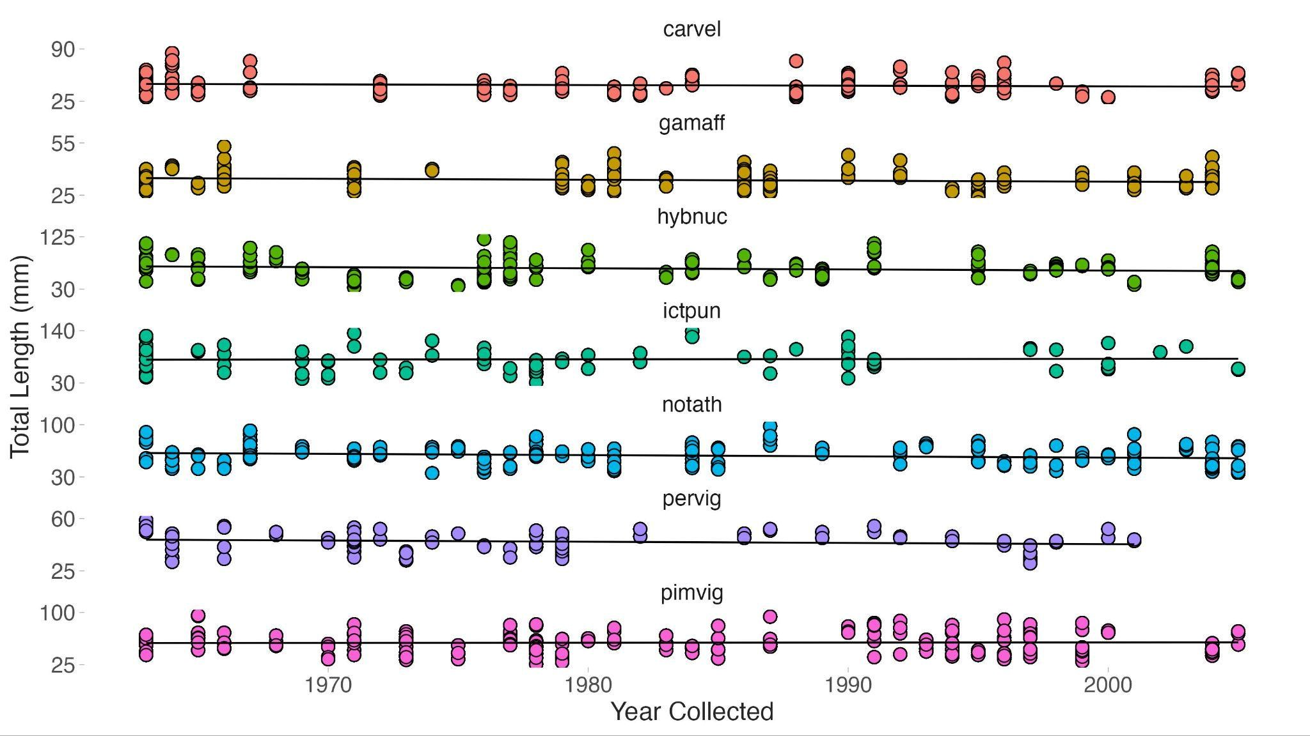
Supplemental Figure 9. Fish body size (total length, in mm) through time. Each facet represents one fish species (gamaff = Gambusia affinis, carvel = Carpiodes velifer, hybnuc = Hybognathus nuchalis, ictpun = Ictalurus punctatus, notath = Notropis atherinoides, pervig = Percina vigil, and pimvig = Pimephales vigilax) and black lines are linear regression lines. The flat slope of the line indicates insignificant relationships between total length and time across all fish species measured.

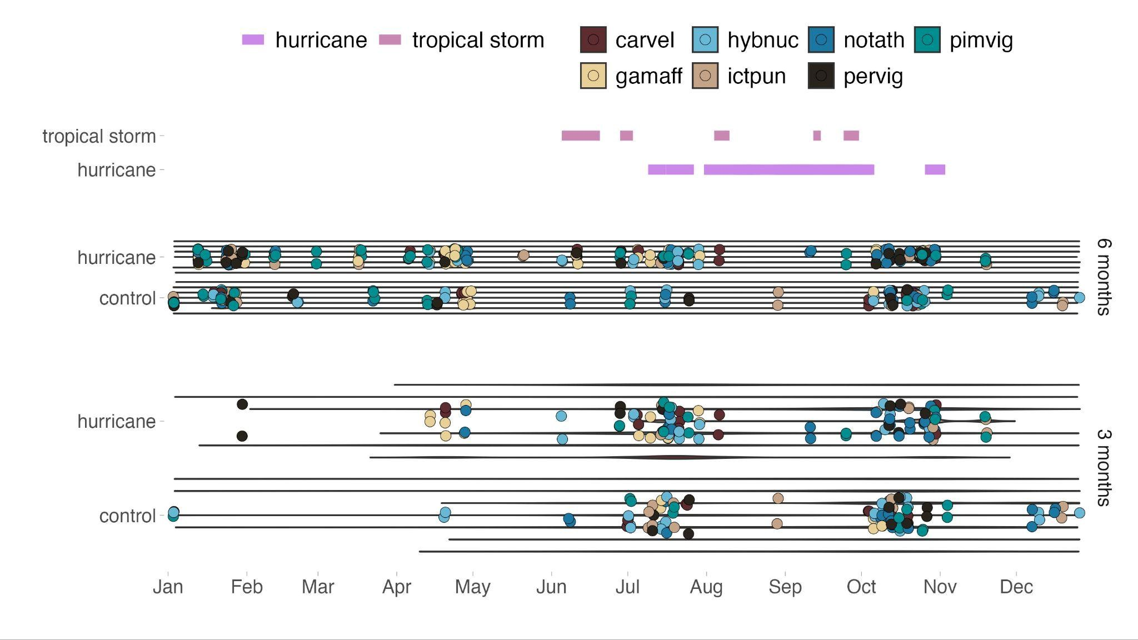
Supplemental Figure 10. Effect of season of collection on transmission strategy analysis. Datapoints were assigned an arbitrary year of occurrence to their accurate day/month (in this case 2025) in order to map collection across one year to assess seasonality. Width of bars represents higher counts of fish lots and raw data are depicted as dots where color corresponds to fish species. The colored bars at the top represent when tropical storm and hurricane events occurred in the assigned representative year.

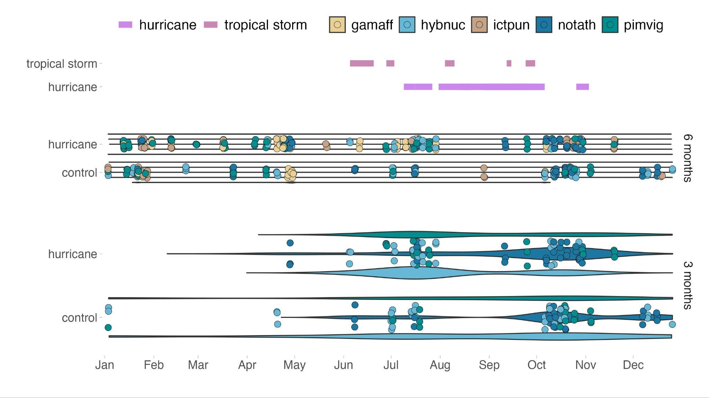
Supplemental Figure 11. Effect of season of collection on parasite taxonomic group analysis
(monogeneans, trematode adults, and trematode metacercaria). Datapoints were assigned an arbitrary year of occurrence to their accurate day/month (in this case 2025) in order to map collection across one year to assess seasonality. Width of bars represents higher counts of fish lots and raw data are depicted as dots where color corresponds to fish species. The colored bars at the top represent when tropical storm and hurricane events occurred in the assigned representative year.

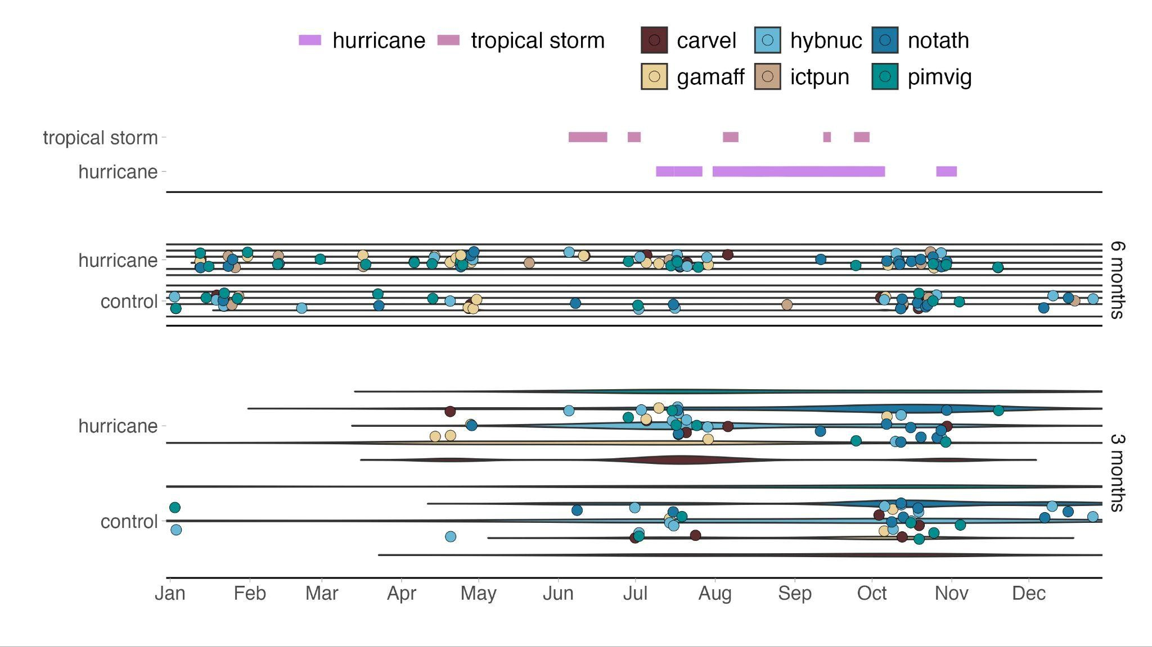
Supplemental Figure 12. Effect of season of collection on myxozoan abundance analysis. Datapoints were assigned an arbitrary year of occurrence to their accurate day/month (in this case 2025) in order to map collection across one year to assess seasonality. Width of bars represents higher counts of fish lots and raw data are depicted as dots where color corresponds to fish species. The colored bars at the top represent when tropical storm and hurricane events occurred in the assigned representative year.

